**User requirements document.**

For the top 15 active/pound for pound fighters.

1. **Target Audience:**

We have a large but specific target audience. Our website is aimed towards fans of the UFC firstly. We hope to provide these fans with up to date information about the ever changing top 15 pound for pound fighters.

Our site is then geared towards fight fans who may prefer other promotions such as Bellator. Our site will hopefully allow these fans to compare the UFC’s top 15 pound for pound fighters against those in other promotions.

Lastly our site is geared towards amateur fans who might just be interest to learn who the top 15 pound for pound fighters are, and a little bit about them

**B)    Our competitors:**

Our main competitor for giving an up to date ranking of the top 15 pound for pound fighters is the UFC’s website. We are confident that an unbiased fan site will be a very popular with other fans.

Another one of our competitors is a fan made site called Tapology. What sets us apart from their site is that their rankings are not official they are based off of fan choices.

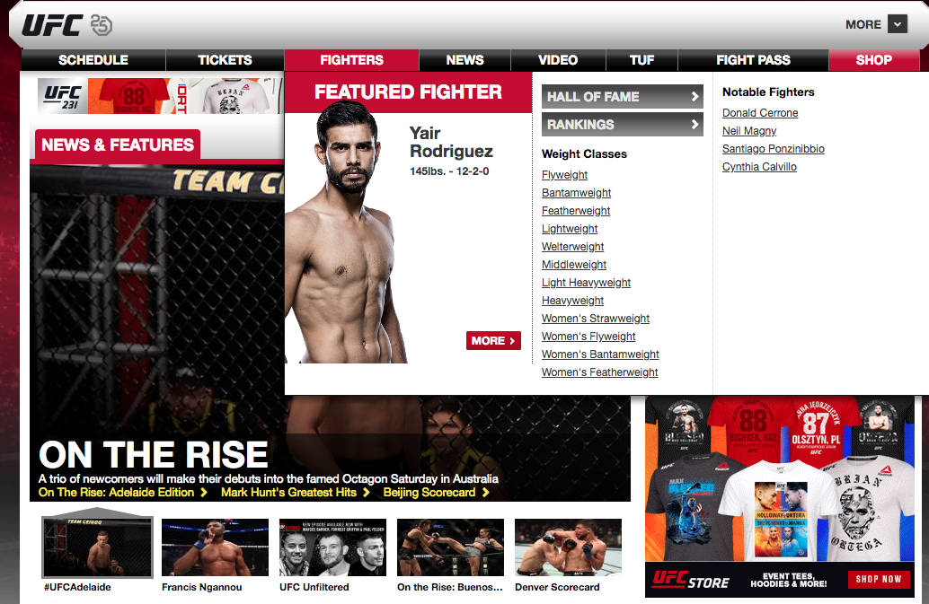

Date accessed 29/11/18

(UFC, Home, 2018)

This is our competitor, the UFC’ website. There is a lot going on in this website. There is no immediate heading to bring us to the pound for pound rankings, you have to go searching through the UFC’ site to find it. As well as this there is also ad’ to the right of the UFC’ website and to the top too. The ad’ change to show different merchandise you can buy from the UFC’ store. I think That they add to the already cluttered screen. There is almost no empty spaces on the website and this makes it difficult to know where to look.

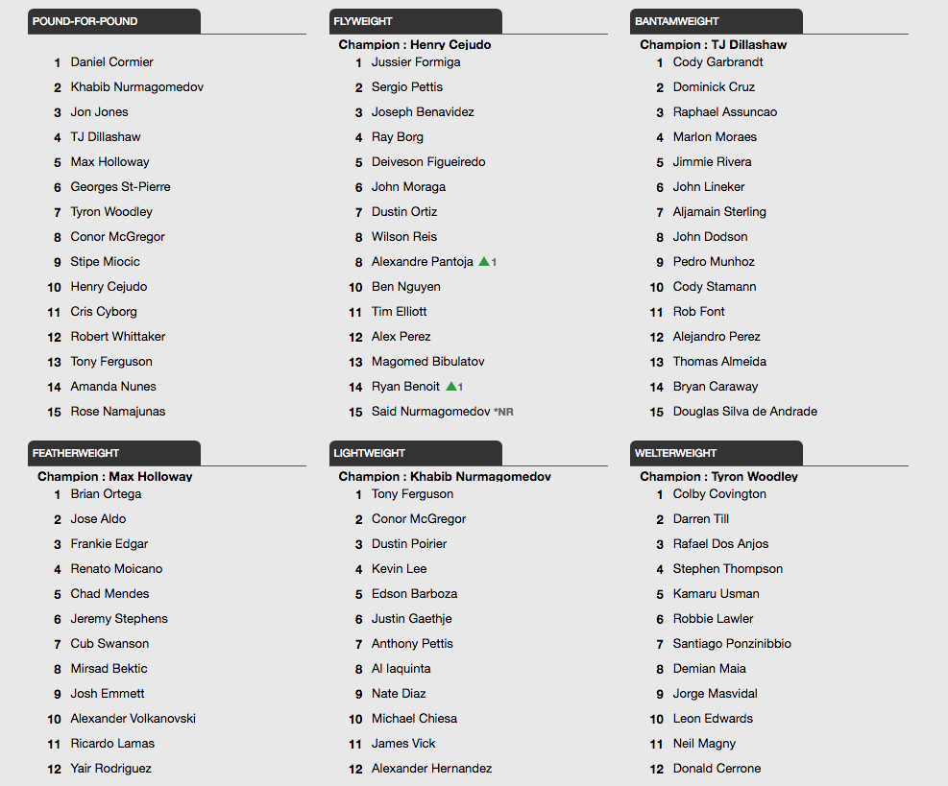

Date accessed 29/11/18

(UFC, UFC Fighter Rankings, 2018)

When you finally navigate to where the pound for pound rankings are held, you are met by 5 other listings. The listings all look very similar. If you take a quick glance at this page it is near impossible to know exactly what rankings you are looking at. This is why on our website we have to pound for pound rankings clearly displayed so that the user knows exactly what they are looking at.

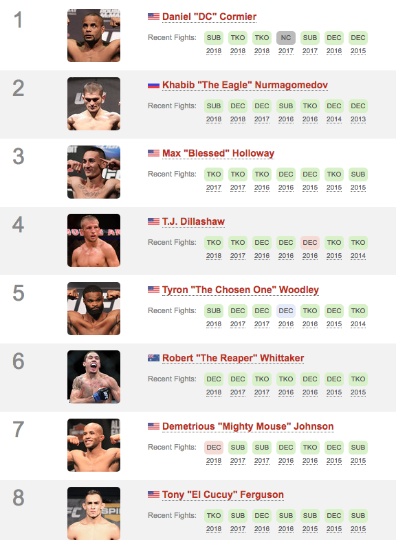

Date accessed 29/11/18

(Tapology, The current best Pound-for-Pound MMA fighters, 2018)

This picture is from the fan made site Tapology. Tapology base their top 15 pound for pound rankings based on fan opinions. This is not the official Rankings from the UFC. To an amateur fan of the UFC this might look like the official rankings, which it’s not. Our website is easy to use and has the official UFC rankings too.

1. **Methods of research:**

To create such an accurate website we had to use multiple methods of research. First we found out who the top 15 pound for pound fighters were. Then we watched highlights of these fighters to get familiar with their techniques and fight style. This helped to give us information to use about the fighters.

After this we researched the fighters professional records, we believed that this would be something that the user would like to know about the fighters.

We have also made a survey that asks people general questions surrounding fighters/fighting in the UFC. Questions vary from, “Would you use a website that showed the top 15 pound for pound fighters” to, “How often do you watch fights live”. The survey will help us to give more details about what the users would want on our site. This made it easier for us to determine what to put on our site.

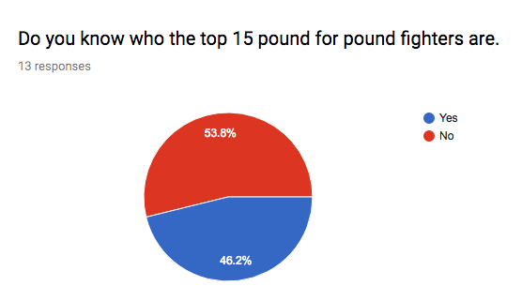

This is our first question on the survey. As you can see from the results the majority of people don’t know who the Top 15 Pound for Pound fighters are, however the margin between “Yes” and “No” is very slight. For us this is a good result as our website is based on the pound for pound rankings. We hope that the people who don’t know who the top fighters are will be more likely to click on our website to find out who they are.

1. **Results of our research:**

Our various methods of research gave us very important results.

Watching highlights proved effective as we learned a lot about the fighters style and common moves they use. The survey proved to be the most beneficial method of research. We learned some surprising results from our survey such as the majority of people would prefer a dark background with white text. The survey helped us create our website around what the user wants.

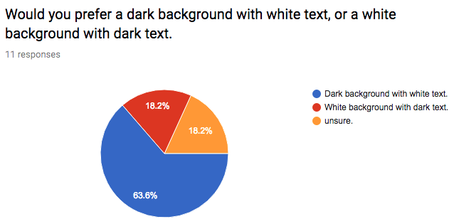

This result had a big impact on the design of our website. Due to this result we made our background colour black and our text white. We learned from our lecture notes that users prefer a white background with dark text, this is why this result shocked us.

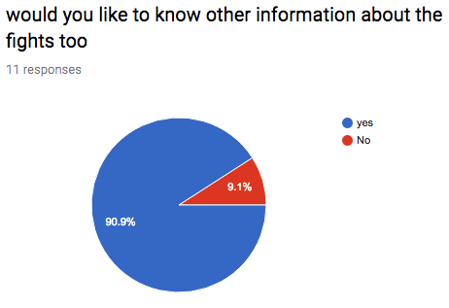

90.9% of people who took our survey said that they would like to know some information surrounding the fighters. Due to this we added basic information about the fighters, such as: where they train, how many fights they have had and what fighting style they have.

1. **Goals of the application:**

Our main goal of this application is to provide quick and easy access to the current top 15 pound for pound UFC fighters. As previously shown the UFC’ website is confusing to navigate through, unless you were familiar with the site it is tough to find the pound for pound rankings. We believe our site to be easier to use and more user friendly .We hope to update our website site as often as the rankings change. We think that this is very important as user will be more likely to keep using our site in the long run if they know we update all our information. Our final goal is to educate more and more amateur fans about the pound for pound rankings.

**Font**

Our website follows the same font layout throughout our website, white text on a black background. Through responses on our survey we found that users prefer a dark background with white text. The white text on a black background really pops. Throughout our various pages on our website the white text stands out on the black background, due to this it makes it very easy for the user to see where the text is. For example if we used a dark blue background colour with light blue text colour it would be difficult for the user to follow the text. Due to the sharp contrast between the colours white and black the user can clearly see and follow the text. On each of the pages dedicated to the fighters, we use the same layout with regards to font. The text is left aligned underneath the image of the fighter. We positioned it here as through reading of our lecture notes we found that users read from left to right like a book.

We used font size h2. We did this as we wanted the text to be big enough that the user can read it with ease yet not to big that it looks out of proportion on the site. As well as this we didn’t want to make the text too small either as users might find it harder to read. Due to these reasons, as a group we decided that font size H2 was a good balance of size, not too big and not too small. We believe we made the right choice with our font size.

We used a normal font style throughout our website. We wanted to keep everything very simple. We didn’t want to make reading our text a difficult task so we decided to keep our font-style simple. Our font style is like that of a book. This would make it a simple task for users to read the text. For example if we used a difficult to read font users might skip reading the information about each fighter.

**Navigation**

We decided to keep the navigation on our website very simple and easy to use. On our home page we have 15 buttons. Each button is named after the fighter it links to with the fighters rank on the Pound for Pound rankings. The buttons on the homepage page are in the top centre of the page. They are placed just under the title of the page. These are the only piece of writing on a page, so the users eye is going to be drawn to the centre of the page immediately. When any button is clicked the user is brought to that fighters page. On all of the fighters pages there is a button that links to the home page. The writing on the button says “Home”, so the user knows where the button will bring them. The “Home” button is placed above the image of the fighter. The button is white and is on a black background so it is easy to see.

We have the padding on each button set to 0.5em, we did this as we wanted a small equal spacing between each button to make it look a bit neater. We didn’t want the 15 buttons on the home page to be on top of each other. The 0.5em also give the buttons rounded corners. As the borders on our website have rounded corners we decided to keep the theme of rounded corners this is why the buttons also have rounded corners.

**Background Colour**

Our website is deigned to be presentable and easy to use for the user. We believe we have made the best website for user accessibility compared to other websites that are oriented for displaying the UFC pound for pound rankings. One aspect of our website that outcompetes the design of these websites is our use of colour.

The colours we used for our website are black and white. These colours make it easy on the eye for the user and allow them to use our website without difficultly for the fact that these two colours contrast from each other and stand out. We have an image of the UFC octagon that takes up two thirds of the home page and it is predominantly white with “UFC” in black on the canvas. This makes it visible to the user that they are on a website that is about the UFC. The fact that the octagon takes up a lot of the page makes the user feel like they are inside the octagon which additionally makes the user aware that they are on a website about the UFC.

Above the image of the octagon we have laid out the top 15 pound for UFC fighters in white boxes with the name of the fighter and their ranking in black text. These buttons are links that direct the user to the page of the fighter they clicked on. We have designed it so that the white boxes have a black background behind them so that it stands out to the user. Furthermore the black text inside the white box makes it easy for the user to read. The area of the buttons take up one third of the width of the page and are located in the centre top of the homepage so that it is one the first things the user sees when they enter our website.

The main title of our homepage is “Top 15 Pound for Pound fighters in the UFC”. This text is white and has black background with makes it clear for the user to see. The text is in bold so that there is more area of white text so it stands out more.

**General description and placement of image**

Home image:

Originally, we had planned to put the image on our home page as the background, but we found out that our potential audience prefers the image to not take up the entire screen. Due to this factor we made the image of the UFC octagon take up just a part of the screen in the body while there is a black background to make it aesthetically pleasing to the eye and it matches the image too and blends in. (All images are placed in the same location on each page)

#1 image:

The image for the number 1 pound for pound fighter was easy to pick from as not only does it blend in well with the black background and white text. I centred the image in the body to make it so the name and position of the fighter was left aligned to make it easier to read and the image centred to drag the attention there. It shows off Daniel Cormier with two belts which also helps our audience to gauge why he is the number 1 pound for pound fighter in the UFC as a double champ.

#2 image:

Image 2 is placed the exact same as image 1. This makes it easy on the eye as you don’t need to scan the page looking for it. If they were all in different locations on the page it wouldn’t be as aesthetically pleasing as we planned to make our website. I selected this image for Khabib Nurmagomedov as he has finally got the belt after a hard career but managing to stay undefeated at 27 wins and 0 loses signifies why he should be at the number 2 spot and the image with the belt well suits it.

#3:

This image shows who arguably should be number 1 in the list. I chose this image for him as it shows how intensely he is looking at his opponent. That he is ready to go to war with the man standing across from him in the cage. But I also chose this image of him without any belts to signify his loses. He never lost professionally in his career but as I’m showing him without the belt it shows that he is the one who gave it away. I used it as a symbol that he is the only reason that he is not number 1. So, this image is what I find to be the most impacting and visually pleasing.

#4:

I found this picture to be quite intense to look at. That is why I chose it, I feel like it shows the grit and determination and how emotional a fighter can get when they win their fight. That it truly brings them happiness and for that reason alone I chose this image.

#5

I chose this picture to symbolize the nice side of MMA. That it’s not all blood and fighting but that they do like what they’re doing and are proud of it. It shows that even though they are fighters that they are still people even if this is their job. Although it was quite hard to choose an image for Max Holloway as all the images I found and added in to our website were quite poor quality and no matter what I did I couldn’t improve it and just for the reason of bad quality I’d say that this is the biggest flaw in our images.

#6:

This image of Georges St-Pierre was a hard one to select. To be honest I think this is one of the least significant images on our website due to the fact that it doesn’t show too much about him or his personality other than what he looks like. But this also is impactful in a way. He is one of few fighters who doesn’t enjoy his job so stumbling across a picture of him in a UFC octagon happy is a hard task to come by so I had to settle.

#7:

I found it quite easy to select this image for Tyron. It shows how exhausted you can get after 15mins or less of hard-work and the grit and determination. But it also shows the passion, you can see it in his face the expression he has that he is proud of what he has done and all the training has paid off in the end. I believe after people seeing the passion in this photo it will make them intrigued and maybe get into watching UFC more.

#8:

Here is the fighter that everybody knows. This image isn’t a stereotypical image people would normally use or relate to Conor McGregor and for that reason is why I chose it. I wanted this image to be original and one that people may not have seen yet. I also like the contrast of the flashing lights in the background of the image and then the focus on McGregor which shows off his tattoos that look good with the black background.

#9:

This image has deeper meaning than many may perceive. This image I chose because of the fact that it shows the end results of hard work. That if somebody wants to tone up or join a gym they need something to aim for. I realise that this may seem a bit too deep for this image but I truly felt this the first time I saw the image I was wondering how I could get myself to look half like that, so I hope people will feel the same and take some motivation from this image.

#10:

The shine off of the UFC belt and the shine of the fighters smile in contrast to the black background of the image and of the background of the site is what made me choose this. I found it to be the most visually pleasing image while also letting you feel a connection to the fighter as you can see his emotions. That he is happy after beating who used to be the #1 pound for pound fighter in the world before he changed organizations.

#11:  
The face paint on the first female fighter on the list showing off how proud she is of her country is why this image is in our website. I wanted to show that the fighters are doing this for the pride of themselves and for the pride of their country. I believe it really draws the eye to the fighter.

#12:

The tattoos, the flag & the UFC belt were the main reasons that I chose this image. I find this image aesthetically pleasing as the dark background fits in well with our site and the tattoos with the background of the flag suit really nicely. The tattoos might also make people research him as I know that a lot of people nowadays are very interested in tattoos and different cultures so I hope that this image will make people want to research more into the fighters culture and fights.

#13:

I chose this image for Tony Ferguson as it shows the dark side of MMA. The blood on his face compared to the pale skin is quite a good contrast and it shows the user that even though fighters can be happy, they do still have to go to war and will get injured. That is their job. But I also think this will attract people to the fighter as everybody likes an exciting fight so this is why I chose this image.

#14:

This fighter is wearing a suit jacket in this photo showing the professional side. I believe it is important to show the user that in the end it is indeed only business and they’re doing this for the love of it and for cash.

#15:

I chose this fighters image really carefully as she herself made a symbolic gesture by shaving off all her hair. She did it to signify that it is a fight sport and not a beauty contest which I think is shows that she is a profound thinker and really doesn’t care what people think. That’s why I decided to include this image as I think her story itself holds a lot of significance.

**Selection of elements**

Nav element = We put our buttons into the nav element, we did this as it would make styling all the buttons easier, and we could ensure that all the buttons looked the same. We placed 5 buttons in each different nav ID so that we could line the buttons up and make it look aesthetically pleasing. In the CSS we were able to style the buttons all the same. We were able to align the buttons to the centre. We were also able to use padding to give all of the buttons rounded corners.

Div ID = We used Div Id’ on our image on our home page. We did this to make it easier to style our image. As we wanted our home page image to take up the majority of the home page, we had to use a Div ID to style the image. In CSS we were able to put the width to 100% and give it rounded corners.

<P> = On all of our fighters pages we have the <P> element. We have to text about each fighter in these, we put the text in here, so it was easier to identify the text on the HTML page.

<H2> = We used <H2> element to give the text the right size for our site. We experimented with other sizes too. <H1> seemed to big and was out of proportion on our website. <H3> seemed a little bit to small, whereas <H2> was just right for our website.

Img ID = We use (Img ID) on all of our fighters’ picture on each of their respective pages. Due to using Img ID we were able to edit all of the pictures the exact same, this gave user a similar feel on each web page. In CSS we were able to style the images the same the same. We position the images in same position and gave them rounded corners.

**Group Contribution**

All members contributed to all areas of this project.

Joseph Kelly X00153381-

HTML

Home page,

CSS,

Design Document = selection of elements, Images

Harry Jenkins X00153536-

HTMl,

User requirement document,

Design Document = Font, navigation.

William Kenny X00153214-

Design Document = background colour,

Css.

Research.